**QUIZ 3 Part-2 Week 7-8-9**

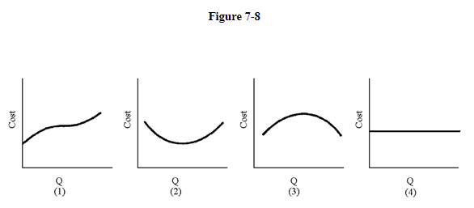

1. Of the graphs in Figure 7-8, which resembles marginal cost?

a. 3

b. 4

c. 2

d. 1

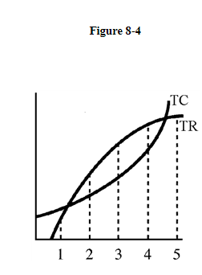

2. In Figure 8-4 at output level 2,

a. the slope of the total profit curve is negative.

b. there are negative profits.

c. MR > MC.

d. marginal revenue is rising compared to output.

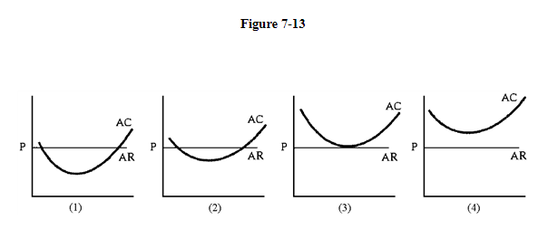

3. Figure 7-13 shows the average total cost curves of four firms that produce milk. Some of the dairies are more productive. AR = P is the long-run price of milk. How many of these dairies will remain in the industry in the long run?

a. only 2

b. only 3

c. all of them

d. cannot determine with information given

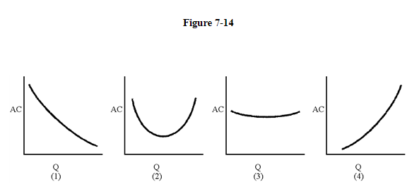

4. Of the long-run AC curves in Figure 7-14, which displays increasing returns to scale for all levels of output?

a. 3

b. 4

c. 1

d. 2

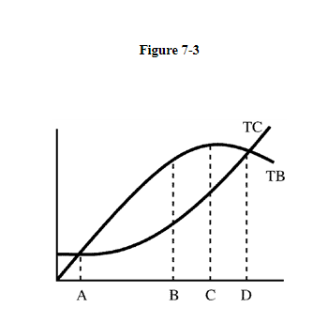

5. Government provides many goods and services to the public because they are not provided by free markets. Some economists believe bureaucrats who manage the programs have no interest in maximizing net benefits (profits) but instead maximize the size of a program constrained only by the need to have total benefits exceed total costs. Figure 7-3 shows total benefits and cost curves for a program. What point is the efficient point, and what point will the bureaucrat choose?

a. D and C, respectively

b. B and D, respectively

c. A and B, respectively

d. D and A, respectively

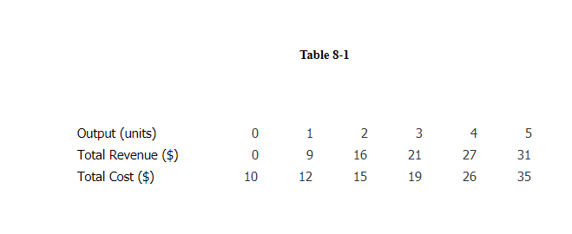

6. To maximize its profits, the firm described in Table 8-1 should produce ____ unit(s) of output.

a. 2

b. 3

c. 4

d. 1

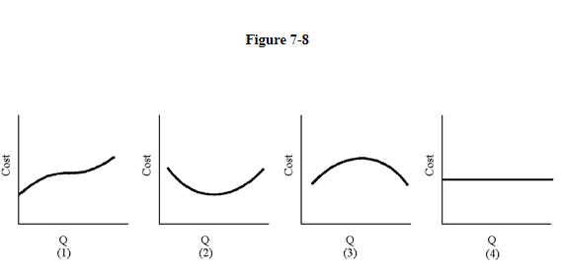

7. Of the graphs in Figure 7-8, which represents total cost?

a. 2

b. 3

c. 4

d. 1

8. Sally leaves her $24,000 secretarial position with a company and invests her savings of $15,000 (on which she was earning 6 percent interest) in her own Ready Sec agency. After expenses, her net income was $28,900. Her economic profit was

a. $4,000.

b.−$10,100.

c. $4,900.

d. $28,900.

9. An airline can profit by offering standby customers an unsold seat at a substantial discount just before take-off because

a. additional passengers are needed to balance the load.

b. such passengers add more to profits than do those with reserved seats.

c. the marginal cost of additional passengers is very small.

d. additional passengers add little to fixed costs.

10. If the random walk theory is correct, a prudent investor might choose her stock portfolio by

a. spending time analysing past stock performance.

b. throwing darts at the newspaper's financial page.

c. spending money to consult a stock forecaster.

d. not investing in stocks at all, since price behaviour is completely erratic.

11. Recently, Chrysler bonds with a face value of 100 closed at 103. The coupon rate was 12.75. The current yield on these bonds was

a. less than 12.75 percent.

b. 3 percent.

c. 12.75 percent.

d. 103 percent.

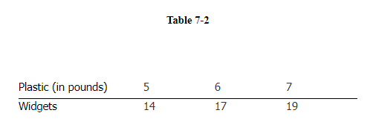

12. Table 7-2 contains information on widget production. The average physical product of the seventh pound of plastic is calculated as ____.

a. 25/9

b. 9/25

c. 19/7

d. 2

13. Everything else equal, the AC curve will shift downward if

a. output rises.

b. output falls.

c. input MPPs rise.

d. input prices rise.

14. If at an output of 4,000 units Sloan Company is making an economic profit and marginal profit is $20 per unit, the firm should

a. increase output until marginal profit falls to zero.

b. reduce output to maximize total profit.

c. There is not enough information to make a decision.

d. do whatever is necessary to increase marginal profit.

15. When marginal cost exceeds marginal revenue,

a. marginal profit < 0.

b. marginal profit + marginal cost > marginal revenue.

c. Marginal cost < marginal revenue − marginal profit.

d. the firm should increase output.

16. Whenever average cost exceeds marginal cost,

a. average cost is falling.

b. average cost is rising.

c. marginal cost is falling.

d. marginal cost is rising.

17. On Naomi's pig farm, Naomi hires all the labour used, grows all the grain fed to the pigs, and owns the barn. The costs used to calculate the total cost curve include

a. only the cost of labour and the cost of grain, which is completely consumed in the period in which it is grown.

b. the cost of labour, the cost of growing grain, and the opportunity cost of the barn.

c. only the cost of labour.

d. only the variable cost of growing grain.

18. A factory produces 1,000 radios a year, AVC = $10 and TFC = $5,000. The factory's TC

a. equals $15,000.

b. cannot be determined from the information given.

c. equals $15.

d. equals $5,005.

19. If the firm's marginal physical product is 8, and its handicrafts sell for $70, at a labor cost of $150, the firm is operating

a. at the optimum input point.

b. short of an optimal input point.

c. There isn't enough information to determine if the input point is optimal.

d. beyond the optimum input point.

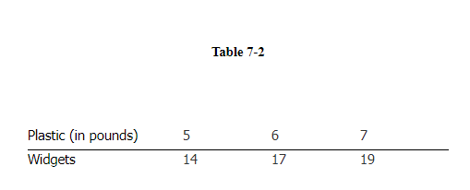

20. Table 7-2 contains information on widget production. The marginal physical product of the sixth pound of plastic is ____.

a. 2

b. 3

c.(19/7) − (17/6)

d. 1/3